Lawrence Zielinski
World War I Military History
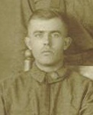

Apr 6, 1917 | United States declared war on Germany, entering the "Great War". Wisconsin National Guard was organized.
May 9, 1917 | Five days before his 21st birthday, Lawrence enlisted in the Wisconsin National Guard as a Private 1st Class, and was assigned to Company "E" of the 4th Wisconsin Infantry Regiment. Company "E" consisted of 150 enlisted men - all from Menasha.
Jun 5, 1917 | Congress passed law requiring all men of draft age to register for the draft. Lawrence registered same day.
Jun 19, 1917 | Wisconsin National Guard units activated at their armories.
Jul 15, 1917 | Wisconsin National Guard ordered into federal service by President Woodrow Wilson.
Jul 18, 1917 | 32nd Division of the U.S. Army organized under War Dept orders. 32nd to be made up of National Guard troops from Wisconsin and Michigan. Monthly pay for Private 1st Class established at $30 plus 75 cents per day.
Aug 5, 1917 | By proclamation of President Wilson, every soldier in the National Guard of every state was essentially discharged from the Guard and immediately drafted into the U.S. Army. This was done because of a constitutional restraint upon the use of Guard troops beyond the borders of the United States. Lawrence entered the Army as a Private, and assigned to Battery "B" of the 121st Field Artillery Regiment of the 57th Field Artillery Brigade of the 32nd Army Division. The 32nd would become known as the "Red Arrow" Division, their symbol a red arrow with a line thru the shaft to signify the division's knack of piercing thru enemy defenses.
Aug 15, 1917 | By this date, Lawrence would have reported to Camp Douglas, Wisconsin, along with the rest of the 4th Regiment.
Sep 12, 1917 | Lawrence honorably discharged from the Wisconsin National Guard due to being drafted into the U.S. Army.
Sep 25, 1917 | 4th Wisconsin Infantry Regiment departed for Camp MacArthur, Texas, near Waco, where they would spend several months training and preparing for overseas duty.

Sep  ’17  -  Feb ’18 | Camp MacArthur, Texas  Named after Lt. General Arthur MacArthur, who dedicated the site, Camp MacArthur One of sixteen National Guard Training Camps established in 1917 to train World War I National Guard units and organize them into Federal divisions. The reservation encompassed some 10,700 acres. The camp was to have a capacity of 45,000 men. It was completed in November 1917 at an eventual cost of $4,500,000. The first commander of the Camp was Major General James Parker who formed the 32nd U.S. Infantry Division and organized the training of the troops. The first elements of the 32nd arrived at Camp MacArthur in August 1917 and began departing for France in January 1918. At the end of the war Camp MacArthur became a demobilization center until it was abandoned on 15 May 1919.  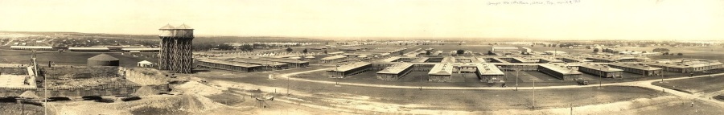
Organization of the 32nd Division in 1917
32nd Division Headquarters - MG James "Galloping Jim" Parker, commanding
- 63rd Infantry Brigade
  - 125th Infantry Regiment - Michigan
  - 126th Infantry Regiment - Michigan
  - 120th Machine Gun Battalion - Michigan
- 64th Infantry Brigade
  - 127th Infantry Regiment - Wisconsin
  - 128th Infantry Regiment - Wisconsin
  - 121st Machine Gun Battalion - Wisconsin
- 119th Machine Gun Battalion - Wisconsin
- 107th Engineer Regiment - Wisconsin and Michigan
- 107th Field Signal Battalion - Wisconsin and Michigan
- 32nd Military Police Company
- 57th Field Artillery Brigade
  - 119th Field Artillery Regiment - Michigan
  - 120th Field Artillery Regiment - Wisconsin
  - 121st Field Artillery Regiment - Wisconsin
    - Battery B - Green Bay, Wisconsin ***Lawrence's unit***
  - 147th Field Artillery Regiment
  - 107th Trench Mortar Battery - Antigo, Wisconsin
  - 107th Mobile Ordnance Repair Shop
- 107th Train Headquarters
  - 107th Supply Train - Wisconsin
  - 107th Sanitary Train - Wisconsin and Michigan
  - 107th Ammunition Train - Wisconsin
    - Company A - Menasha, Wisconsin
  - 107th Engineer Train
  - 107th Motor Supply Truck Unit
- 158th Field Artillery Brigade (attached)
  - 322nd Field Artillery
  - 323rd Field Artillery
  - 324th Field Artillery
  - 308th Trench Mortar Battery
  - 308th Ammunition Train
Jan 2, 1918 |  | First troops begin leaving Waco for the port of embarkation in Hoboken, NJ.
Feb 1918 |  | Artillery regiments begin movement to Hoboken.
Mar 3, 1918 |  | U.S.S. Leviathan left Hoboken, NJ with the 120th and 121st FA units among others, destined for Europe.
Mar 20, 1918 |  | 120th and 121st Field Artillery units arrive in LeHavre, France. The 57th Field Artillery Brigade was sent to the artillery training area at Camp Coetquidan in Brittany, France, near Prauthoy.
mid Jun 1918 |  | In the middle of June, the 57th Field Artillery Brigade joined the rest of the 32nd Division in Alsace, France, and a few days later was firing in support of the infantry. The 32nd was sent here to complete its combat training in order to prepare to be sent to a more active sector in the future. This area was considered a quiet sector; no major combat activity was taking place in this area at the time. Aggressive patrols and raids were the normal activity here. Patrols from both sides met met and clashed in "no man's land" almost nightly.
Jul 19, 1918 |  | 32nd Division begins to pull out of the Alsace area bound for a more active area.
Jul 24, 1918 |  | Entire 32nd Division in vicinity of Pont St. Maxence, southwest of Soissons.
Jul 26, 1918 |  | 32nd Division began arriving in the Chateau-Thierry region just after nightfall, joining the 6th French Army in the tip of the famous Marne salient.
Jul 27, 1918 |  | Regiments lined up on Paris-Metz road and began marching towards the front.
Jul 28, 1918 |  | 32nd Division reached its destination and bivouacked in the Foret de Fere, near le Charmel.
Jul 29, 1918 |  | Elements of the 32nd in position in the vicinity of Roncheres, France.
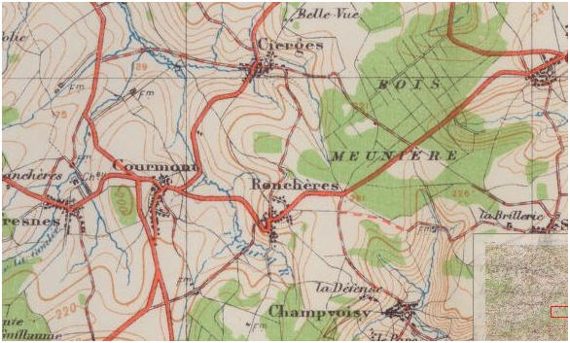
Jul 30, 1918 | The 32nd Division received its baptism of fire (first major offensive action) at 1430 hrs when the 127th Infantry went over the top and followed a rolling barrage into the Bois des Grimpettes. The 127th pushed through the woods until they were stopped by machine gun fire from the right flank. On this flank, from positions in the Bois de Cierges, the Germans continued to oppose every effort to advance, but the 127th Infantry gained the edge of those woods and established themselves there. During the night the Germans launched a counter attack from the Bois de Meuniere and a bayonet melee raged for hours in the dark, tangled woods, until the attacking force was finally routed.
Aug 7, 1918 | The fighting raged for the next 8 days. The 32nd fought it's way from Roncheres, through Cierges and Bellevue Farm, and ending with the capturing of the town of Fismes. It was during the battle for Fismes that the 32nd earned the nickname "Les Terribles".
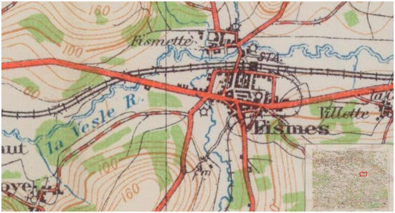
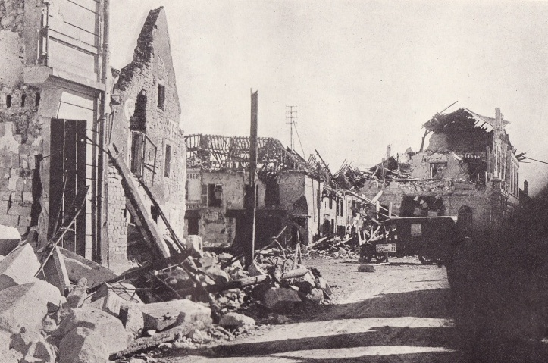
Fismes
Aug 7, 1918 | 32nd Division relieved in the front, except for the 57th Field Artillery which remained in action to support the 28th and 77th divisions.
Aug 23, 1918 | 32nd Division started movement to a new sector, in the vicinity of Perrefonds, near Soissons.
Aug 28, 1918 | 32nd Division returned to action in the battle for Juvigny. They attacked the town from the west in the morning and made some progress, but holding ground was a difficult task. They were on high, open ground on the down slope of a hill facing the enemy with little cover. Shortly after noon, the Germans counter-attacked, but the Americans held their ground aided by the Field Artillery, and were able to repel the counter-attack.
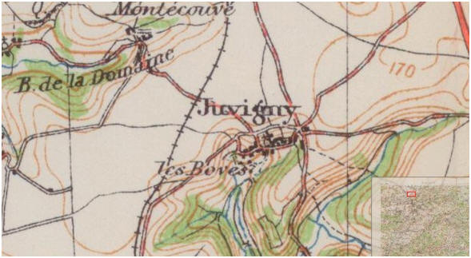
Aug 31, 1918 |  |  | As the battle for Juvigny continued, the 57th Field Artillery Brigade formed a triple, rolling barrage of artillery covering a depth of about 1.5 km. Even with all this firepower, the 32nd suffered considerable casualties, but in the end, met their objectives and captured the town. The general advance was stopped at the Terny-Sorny road.
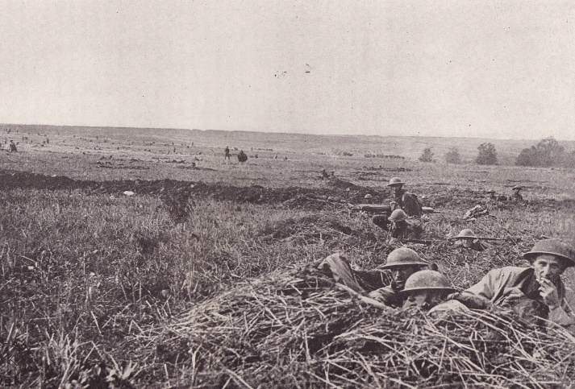
near Juvigny
Sep 1, 1918 |  |  | 32nd Division relieved from the front and went into support positions for the 10th French Army. However, the 57th Field Artillery brigade remained to support a Moroccan unit.
Sep 6, 1918 |  |  | 32nd Division began moving to its former billeting area near Pierrefonds.
Sep 10, 1918 |  |  | 32nd Division moved by train to a rest area in the vicinity of Joinville, north of Chaumont.
Sep 22, 1918 |  |  | Orders received to begin movement toward the vicinity of Verdun in a reserve role. The artillery was moved first, marching entirely at night.
Sep 26, 1918 |  |  | Meuse-Argonne offensive began with the 32nd in a support role in position in the Foret de Hesse.
Sep 29, 1918 |  |  | Orders received for 32nd to move forward and relieve the 37th. The move was difficult - 11 miles on foot through the cold, dark, rainy night over ground strewn with deep shell holes, broken barbed wire, broken trees and brush, with 78 pound packs on their back.
Sep 30, 1918 |  |  | 32nd Division lined up in battle array before the town of Cierges-sous-Montfaucon (not the same Cierges from July 30)
Oct 3, 1918 |  |  | In preparation for a new attack, the 32nd was ordered to relieve the 91st.
Oct 4, 1918 |  |  | 32nd Division wrested control of the village of Gesnes-en-Argonne after a punishing artillery barrage, but could not occupy it. With the Americans south of the town and the Germans north, Gesnes became a no-man's land.
Oct 5, 1918 |  |  | 32nd Division renewed it's attack on the village of Gesnes-en-Argonne. The Germans were entrenched in fortified positions in the forests just outside of town. Gas and flame troops and tanks were assigned to the attack. The 32nd was successful, but the battle lasted for 3 days.
Oct 8, 1918 |  |  | A new front line was established about 2 km north of Gesnes. The 32nd Division was now directly in front of the Kriemhilde Stellung, one of the strongest positions of the entire Hindenburg line. The remainder of the day was devoted to positioning soldiers for the attack.
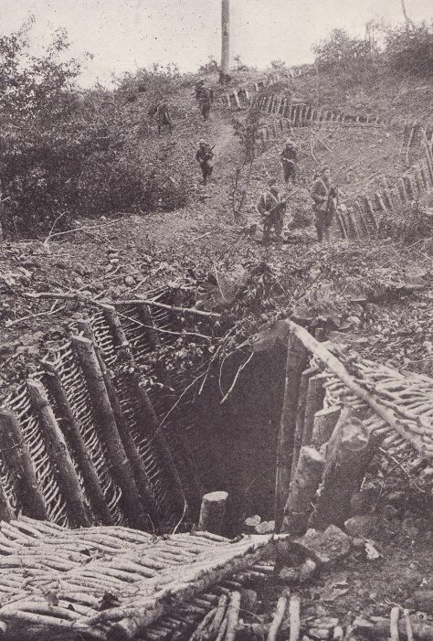
Kriemhilde Stellung
Oct 9, 1918 | In the morning, the assault began. Fighting lasted thruout the day, but the attack was stopped about 1 km south of Romagne. The German commander issued orders to his troops to hold the line at all costs.
Oct 10, 1918 | The fighting continued with the 32nd making very small gains. At some points along the line, they engaged in hand to hand conflict, and finally succeeded in occupying a part of the system.
Oct 14, 1918 | The battle continued to rage with little progress being made. A new attack was made at 0530 with a barrage of artillery laid down on the enemy trenches along the entire front. In some places the barrage damaged the barbed wire enough to get some of the troops through. In other areas, damage was minimal and soldiers getting caught up in the wire were gunned down from machine gun nests. Savage fighting continued however, and eventually the Americans flanked and surrounded the Germans and forced a surrender.
Oct 15, 1918 | The penetration of the Kriemhilde Stellung was completed and a new front line was established 1/2 km north of Romagna. Pockets of fighting continued thru Oct 19th. During this entire period, it had rained almost continuously. Fields were knee-deep in mud, and the nights were cold and raw. There was scarcely an hour of the day or night when they were not under fire. The struggle was over the most difficult terrain that any soldiers in the Great War were ever asked to conquer. For their troubles, the 32nd was kept in reserve until Nov 1st.
Nov 1, 1918 | The 57th Field Artillery Brigade was positioned in support of the 89th Division in the Meuse-Argonne offensive. They fired in the barrage that opened the Nov 1 attack. But, as the 1st Army surged forward, the 57th was without the motive power to follow, and was withdrawn for refitting. They were withdrawn to a resting area where they served with the 40th Division at Revigny, and later with the 88th Division in the Gondrecourt area.
Nov 9, 1918 | Orders received for the 32nd to cross the Meuse and move up to the front lines. That night they crossed the river under cover of darkness on pontoon bridges at Dun-sur-Meuse.
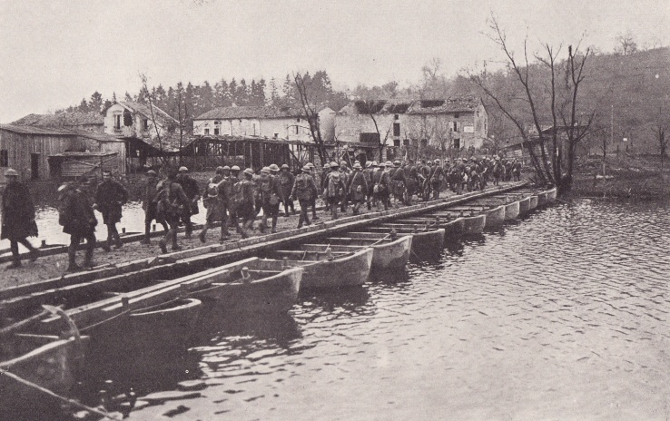
crossing the Meuse
Nov 10, 1918 | 32nd Division went on the attack at 0600. Information from Corps indicated the Germans were retreating. A heavy fog hid the advance, and the troops made rapid progress. They encountered the enemy at once, but fought their way through the Bois Pommepre. At about this time, the fog lifted, and the advance troops discovered that instead of pursuing a fleeing enemy, they had fought their way right into the middle of a strong German position which the enemy had no intention of abandoning. They found themselves almost completely surrounded. As the German machine gunners opened fire, the Americans miraculously were able to retreat back to a more defensible position in line with the rest of the division. By the end of the day, only 3 km had been gained. It had now become obvious that the Germans were not in retreat and a new plan of attack was made.
Nov 11, 1918 | During the night of the 10th and the early morning of the 11th, the artillery unleashed a heavy barrage into the German front lines in advance of a renewed attack.
Nov 11, 1918 | At 5:10 a.m. representatives of the German High Command signed the armistice dictated to them by the Supreme Commander of the Allied Forces, officially ending the Great War.
Nov 17, 1918 | 32nd Division crossed what had been its front line on Nov 11th, and started the long march towards the Rhine, averaging 20 km per day. The first villages encountered were almost uninhabited. In Marville, a modest ceremony was prepared for the arrival of the Division Commander. The countryside was desolate and shot up by the artillery fire of previous engagements.
Nov 18, 1918 | 32nd Division reached Longwy, a sizable manufacturing town in the iron and steel district of Lorraine. The entire population of the town was in attendance for a ceremony welcoming the Americans.
Nov 20, 1918 | The march resumed and the division crossed the border into Luxembourg. They marched through the suburbs of the town until reaching it's billeting areas in the vicinity of the Capital.
Nov 23, 1918 | 32nd Division reached the German border on the Saar River near Echternach, Luxembourg. There, the movement would halt until December 1st, as required in the terms of the armistice.
Dec 1, 1918 | The march resumed with the 32nd Division using 3 bridges to cross into German territory. At first the German citizens were restrained, even fearful, of the Americans. After they learned the Americans would not harm persons or property, they became more affable and did all possible to make the soldiers comfortable.
Dec 5, 1918 | As march continued, 32nd billeted for the night in Daun. This was a fairly large city, and it was thought that the attitude of the civilians might be somewhat different from those of the smaller towns. Such was not the case, however, and Daun proved to be well provisioned.
Dec 11, 1918 | The long march continued each day until reaching the Rhine at the confluence with the Moselle, opposite the city of Koblenz.
Dec 13, 1918 | Friday the 13th! 32nd Division began crossing the Rhine into Germany over Engers Bridge.
Dec 14, 1918 | 32nd Division finished crossing the Rhine, and began to occupy its sector of the Koblenz bridgehead.
Dec 18, 1918 | Occupation of the Koblenz bridgehead completed. The sector covered a front of 30 km wide by a depth of 20 km. Life in the Koblenz bridgehead was better than most billets the division had "enjoyed" in France. Most of the men had beds to sleep in, and the food was excellent. The hated training continued, however. The troops either were billeted in, or occupied as outposts, 63 towns. Here they would stay for 4 months.
Mar 15, 1919 | General Pershing reviewed the 32nd Division near Dierdorf, Germany, and bestowed compliments upon the men.
Apr 18, 1919 | 32nd Division started moving back from the Rhine, across France to Brest, on the first leg of the homeward journey.
May 1, 1919 | 32nd Division begins the sail across the Atlantic towards home. By May 15th, the entire division was enroute. The troops sailed to New York, where, upon arriving back in the U.S., a great reception was accorded "Les Terribles". Delegations from Wisconsin and Michigan met the incoming steamers in the harbor. From New York, the 121st Field Artillery were transferred to Camp Grant, Illinois.
May 17, 1919 | 121st Field Artillery Regiment demobilized at Camp Grant.
May 19, 1919 | Lawrence Zielinski honorably discharged from the Army at Camp Grant. Battles engaged included: Rougemont 2nd June 11 - July 23, 1918; 2nd Battle of the Marne July 21 - August 23, 1918; Soissons Front August 28 - September 7, 1918; Argonne 2nd September 23 - November 8, 1918. Lawrence was blessed in that he received no wounds during the war, and was discharged with "excellent" character.
Jun 5, 1919 | Red Arrow Day in Wisconsin. The returning Wisconsin warriors were given an enthusiastic formal welcome with parade through the streets of Milwaukee.
